**Food Resources in Boston**

# General

* For the closest food pantry/bank to you, visit [The Greater Boston Food Bank](https://www.gbfb.org/need-food/)
  + Search your city or zip code for a list of agencies in your community.
  + Select ‘More Info’ for agency hours of operation and phone number. (We recommend calling ahead to verify agency hours.)
* Project Bread works to fully enroll individuals in state and federal nutrition programs (SNAP, WIC, food stamps) as well as refer callers to local food resources. For more information about any of the below resources, call Project Bread's FoodSource Hotline at 1-800-645-8333. Our counselors can assist callers in 160 languages and their is a dedicated line to assist our hearing-impaired community at TTY: 1-800-377-1292 (food assistance for MA residents). Additional info [here](http://www.projectbread.org/get-help/).
* Free groceries at Makeshift Boston (Solidarity Supply Distro) 549 Columbus Ave on Mondays at 5:30pm until the crisis ends. More info [here](https://www.facebook.com/SolidaritySupplyDistro/).
* Daddy Jones Bar in Somerville is offering to help with small meals in the community. Reach them through [Facebook](https://www.facebook.com/daddyjonesbar/photos/pb.139045476187154.-2207520000../2814737978617877/?type=3&theater)
* Trina’s Star Lounge is also offering to help with small meals in the community. Reach them through [Facebook.](https://www.facebook.com/trinastarlitelounge/photos/a.10151514717759930/10157517108664930/)
* Rosie's Place serves unhoused and housing-insecure women and their children. Details on food programs can be found [here](http://www.rosiesplace.org/how_we_help/emergency_services/food_programs).
* Somerville Food Security Connection offers food pantry and community meals. More info [here](http://somervillefoodsecurity.org/get-involved/).
* Action for Boston Community Development (ABCD) at various locations serving Boston, Allston/Brighton, East Boston, Mattapan, Parker Hill/Fenway, and Roxbury/North Dorchester. ABCD offers assistance in food emergency and/or groceries on a regular basis for those who cannot afford it. CALL BEFOREHAND to see if the pantry near you is still open (it has been restricted to 6 locations). You will need any government ID, proof of income, and proof of address (must be from three different sources) to enroll or receive assistance immediately. They usually have at least dry and canned goods stocked for emergency packages. More info [here](https://bostonabcd.org/service/food-pantries/).
* Community Servings delivers meals. Call Client Services team at 617-522-7777. More info [here](https://www.servings.org/meal-faq/).
* Project Soup – Food Pantry at 165 Broadway (corner of Cross Street; same building as Senior Center) Somerville, MA 02145. Contact us at (617) 623-6111 or visit website [here](http://www.somervillehomelesscoalition.org/food-security/).
* Brighton Allston Congregational Church (404 Washington St, Brighton) - Has free/open to all Community suppers every Wednesday at 6 PM. They also have a food pantry and thrift store (free items - see [site](https://brightonucc.org/whatwedo/) for details).
* Free meals to go Wednesday nights and Saturday afternoons at First Baptist Church in JP. Details can be found on Facebook [here](https://www.facebook.com/FirstBaptistJP/).
* Quincy Community Action Programs' Southwest Community Food Center (1 Copeland St. Quincy) offers emergency food and SNAP application services to Norfolk County residents and is open regular hours. Call 617-471-0796 to make an appointment. Hours: Monday, Tuesday, Thursday, Friday 9:00-4:30 and Wednesday 11:00-6:30. More info [here](https://www.qcap.org/our-programs/food-nutrition/#southwest).
* For food delivery in the Cambridge area for low income folks, access [Food for Free](https://foodforfree.org/home-delivery/) and submit an application. Applications are available in English and Spanish
* For access to food in the broader Massachusetts area, call the [FoodSource Hotline](http://www.projectbread.org/get-help/foodsource-hotline.html) at 1-800-645-8333, TTY 1-800-377-1292
* Apply to the [WIC program](https://www.mass.gov/forms/apply-for-wic-online) for women, infants and children nutrition program for assistance buying affordable groceries
* Get help applying for the Supplemental Nutrition Assistance Program (SNAP), formerly known as food stamps
  + Who is eligible? SNAP is for everyone. If you are within the income limits listed, you may be eligible.

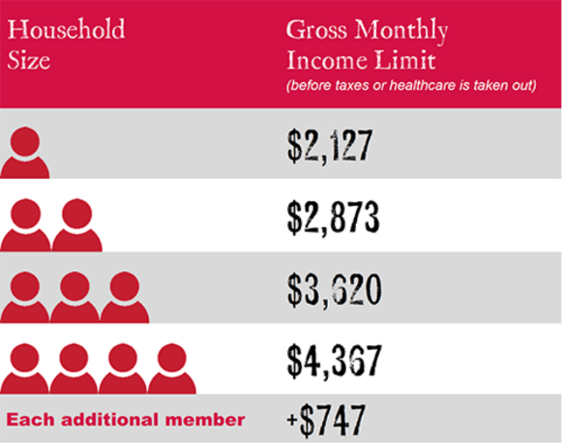

* + Call 617-598-5022 or Email: SNAP@gbfb.org to determine whether you qualify and to get assistance with the application
* Uber EATS is offering ***free delivery***

# Grocery delivery services

* Instacart: <https://www.instacart.com/grocery-delivery/boston>
* Peapod: <https://www.peapod.com>
* Amazon Fresh: <https://www.amazon.com/fmc/learn-more>
* Solidarity Supply Distro to offer [free delivery](https://www.facebook.com/SolidaritySupplyDistro/photos/a.103617487940477/103617374607155/?type=3&theater). Email them [here](mailto:bostonsolidaritysupplydistro@protonmail.com) to request grocery delivery or to sign up as a volunteer.
* Mill City Grows delivers produce to Lowell residents. More info [here](https://www.millcitygrows.org/mill-city-grows-markets/food-access/).

# Food for children and youth

* Boston public schools are closed, but starting on 3/17, youth and teens can continue to pick up food that they would otherwise receive while in school. All pick-up sites are set up to be "grab and go". Please keep six feet between yourself and others when picking up food. Hours of operation vary. [Click here for locations and hours.](https://www.boston.gov/departments/food-access/map-meal-sites-boston) If you need assistance, call 1-781-428-4548.
* Oak Square YMCA: free meals for children in Brighton. Details can be found on Facebook [here](facebook.com/OakSquareYMCA).
* Coronavirus concerns: Jack’s Abby offering free pizza to students in Framingham on Thursday, Friday after schools were closed. More info [here](https://www.masslive.com/boston/2020/03/coronavirus-concerns-jacks-abby-offering-free-pizza-to-students-in-framingham-on-thursday-friday-after-schools-were-closed.html).
* Summer Eats serves free meals to kids & teens while school is out (June, July, & August) at more than 1,100 sites across MA. No registration or I.D. necessary. Just drop in. To find a location: call Project Bread FoodSource Hotline at 1-800-645-8333 or text "FOOD" or "COMIDA" to 877-877. Visit [www.meals4kids.org](http://www.meals4kids.org) for more info.

# Food for the elderly (60+)

* Meals on Wheels will continue to provide services for seniors, with food delivery and pick up options. Meals are available for pick up from 11:30 to 12:30 from community cafes that can be found [here.](https://www.ethocare.org/cororavirus-covid-19-response-community-cafe-open-and-closure-status/) You can sign up for food delivery options by calling 617-477-6606. If you need assistance with translation, while navigating these websites, call 781-428-45-48.
* Somerville-Cambridge Elder Services offers Nutrition and Meals services to help older people and younger people with disabilities remain healthy and independent at home. More details can be found [here](https://eldercare.org/find-what-you-need/nutrition_and_meals/) or by calling 617-628-2601 and request Aging Information.